Course Three

Go Beyond the Numbers: Translate Data into Insights


Instructions
Use this PACE strategy document to record decisions and reflections as you work through this end-of-course project. You can use this document as a guide to consider your responses and reflections at different stages of the data analytical process. Additionally, the PACE strategy documents can be used as a resource when working on future projects.

Course Project Recap
Regardless of which track you have chosen to complete, your goals for this project are:
- Complete the questions in the Course 3 PACE strategy document
- Answer the questions in the Jupyter notebook project file
- Clean your data, perform exploratory data analysis (EDA)
- Create data visualizations
- Create an executive summary to share your results

Relevant Interview Questions
Completing the end-of-course project will help you respond to these types of questions that are often asked during the interview process:
- How would you explain the difference between qualitative and quantitative data sources?
- Describe the difference between structured and unstructured data.
- Why is it important to do exploratory data analysis?
- How would you perform EDA on a given dataset?
- How do you create or alter a visualization based on different audiences?
- How do you avoid bias and ensure accessibility in a data visualization?
- How does data visualization inform your EDA?
Reference Guide
This project has six tasks; the visual below identifies how the stages of PACE are incorporated across those tasks.
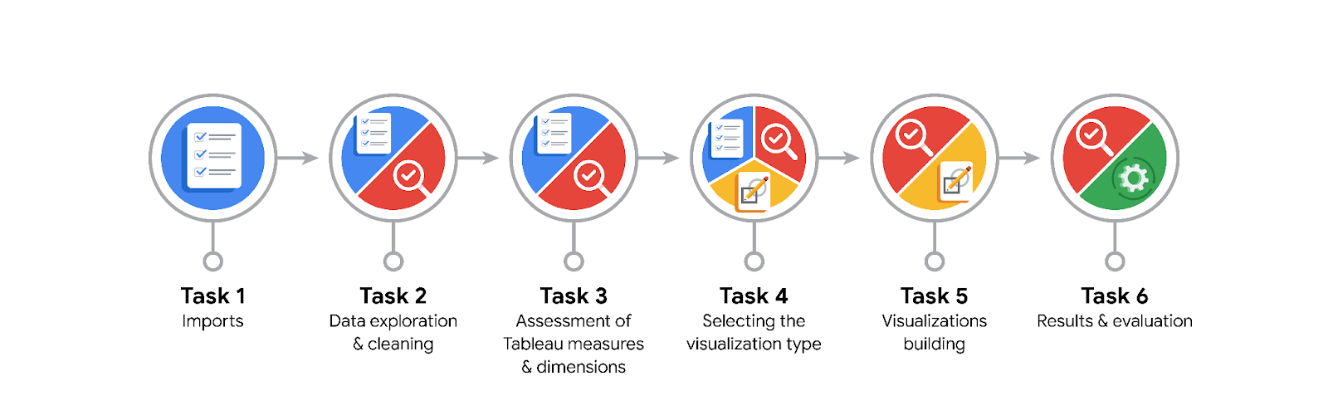
Data Project Questions & Considerations

PACE: Plan Stage
- What are the data columns and variables and which ones are most relevant to your deliverable?
The dataset includes variables such as sessions, drives, total_sessions, driven_km_drives, duration_minutes_drives, activity_days, driving_days, device type, and churn label. The most relevant variables for predicting churn are sessions, drives, driving_days, driven_km_drives, and churn label. These variables represent user engagement, driving behavior, and activity frequency, which directly influence user retention or churn likelihood.

- What units are your variables in?
Distance is measured in kilometers, duration is in minutes, and counts such as sessions and drives are whole numbers. Categorical variables (device and churn label) are represented as string objects and require encoding or separate categorical visualization.

- What are your initial presumptions about the data that can inform your EDA, knowing you will need to confirm or deny with your future findings?
It is hypothesized that users who drive longer distances are more likely to churn, while users who drive more frequently tend to remain active. Additionally, users with a high percentage of sessions in their most recent month of activity may represent reactivated users who recently returned to the platform.

- Is there any missing or incomplete data?
Yes. There are missing values in the churn label column (approximately 700 missing entries). These will be removed from analysis or imputed if additional user history data becomes available. Other columns are complete but include extreme or infinite calculated values that require correction.

- Are all pieces of this dataset in the same format?
Yes, the dataset is mostly consistent. Numeric variables are formatted as integers or floats, while categorical variables such as device type and churn label are stored as strings. These require separate handling during visualization and modeling.

- Which EDA practices will be required to begin this project?
EDA will include data inspection using info() and describe(), handling of missing and infinite values, detecting and winsorizing outliers, creating derived metrics such as km_per_driving_day, and generating visualizations (histograms, box plots, scatter plots, and bar charts) to uncover behavioral insights.

PACE: Analyze Stage
- What steps need to be taken to perform EDA in the most effective way to achieve the project goal?
To perform EDA effectively, I will:
Load and inspect the dataset to confirm structure and data types.
Check distributions, identify outliers, and handle missing values.
Calculate derived metrics (e.g., km_per_driving_day, percent_sessions_in_last_month).
Visualize relationships between engagement metrics and churn.
Each step ensures data integrity and identifies behavioral patterns linked to churn risk.

- Do you need to add more data using the EDA practice of joining? What type of structuring needs to be done to this dataset, such as filtering, sorting, etc.?
No joining is required. However, data consistency must be verified since activity_days has a maximum of 31 while driving_days has a maximum of 30. Filtering and winsorization will be applied to correct outliers and unrealistic driving distances.

- What initial assumptions do you have about the types of visualizations that might best be suited for the intended audience?
Histograms and box plots will display variable distributions and outliers; scatter plots will show relationships between sessions and drives; bar charts and proportional histograms will compare churn rates across devices and activity levels. These visuals support both analytical clarity and executive storytelling.

PACE: Construct Stage
- What data visualizations, machine learning algorithms, or other data outputs will need to be built in order to complete the project goals?
I will create histograms, box plots, bar charts, pie charts, and scatter plots. Derived variables such as km_per_driving_day and percent_sessions_in_last_month will also be visualized to explore churn trends and user engagement patterns.

- What processes need to be performed in order to build the necessary data visualizations?
The dataset will be cleaned to remove or replace missing and infinite values, capped at the 95th percentile to handle outliers, and filtered for realistic driving distances. Proper labeling, scaling, and contrast will ensure visual clarity and accessibility.

- Which variables are most applicable for the visualizations in this data project?
The primary variables are sessions, drives, total_sessions, driven_km_drives, duration_minutes_drives, km_per_driving_day, and churn label. Device and activity variables will be used for categorical comparison and retention rate analysis.

- Going back to the Plan stage, how do you plan to deal with the missing data (if any)?
Rows with missing churn labels will be removed before analysis. Infinite or extreme numeric values will be replaced or capped using winsorization to maintain statistical reliability.

PACE: Execute Stage
- What key insights emerged from your EDA and visualizations(s)?
The churn rate is approximately 17%. This rate is consistent across device types. Users who drive longer distances per day are more likely to churn, while frequent drivers (those with more driving days) tend to stay. Additionally, about half of users had over 40% of their total sessions in the last month, suggesting a sudden increase in engagement among long-term users.

- What business and/or organizational recommendations do you propose based on the visualization(s) built?
Waze should focus retention strategies on frequent drivers who show declining activity and monitor long-distance drivers for potential churn risk. It is also recommended to investigate the recent surge in activity among long-tenure users to determine whether it was driven by an update, campaign, or seasonal factor.

- Given what you know about the data and the visualizations you were using, what other questions could you research for the team?
Why did many long-term users become highly active recently?
Are there regional or time-based trends influencing churn?
What factors explain the difference between activity_days (31) and driving_days (30)?
How does the frequency of app opens relate to satisfaction or feature usage?

- How might you share these visualizations with different audiences?
Insights can be shared through an interactive dashboard or executive presentation. For technical audiences, detailed visualizations (scatter plots, correlation heatmaps) can be included; for executives, summarized bar charts and key performance metrics should be emphasized. Clear color contrast and labeling will ensure accessibility and comprehension.

